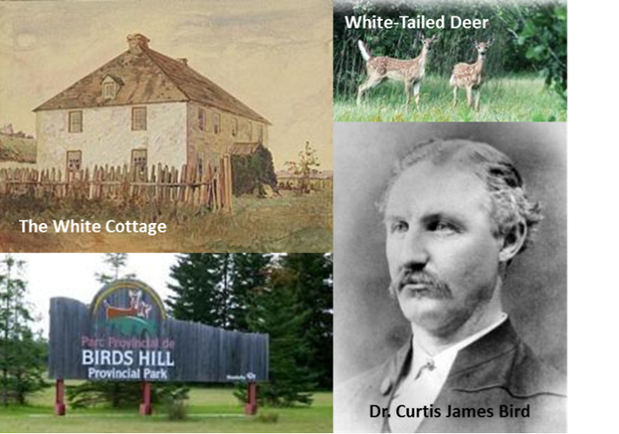Bird’s Hill

Bird's Hill was named for the Bird family, who lived here during the early days of Manitoba settlement. James Curtis Bird (c. 1773-1856) was Chief Factor of the Red River District for the Hudson Bay Company and was renowned for his knowledge of the region. In 1824, he retired from 36 years of Company service and received a 3,000 acre land grant where he built his home called "the White Cottage." The youngest of his 15 children, Dr. Curtis James Bird (1838-1876), ran a drug store with the first soda fountain in western Canada. He also served as the second speaker of the Manitoba Legislative Assembly (1873-4). The Bird's and other settlers called the area 'Pine Ridge,' from which the town southeast of the park derives its name.

Bird's Hill was a great blessing to colonists on the flat prairies. Though the fur trade wars between the HBC and the Northwest Company had ended and the Red River settlement was growing, the flood of 1826 ravaged the colony’s progress. Families fled to Stony Mountain, Silver Heights, and Bird's Hill to take refuge from the water. Some settlers left Manitoba after the flood. Those who stayed would again flee to Bird's Hill in the great flood of 1852.

The terrain of the hill was shaped by the ice age over 3,000 years ago. Boulders left by the glaciers or dropped from icebergs in Lake Agassiz can still be seen lying around the park. The glaciers also left large deposits of gravel which began to be mined in the early 1900s. This gravel was used in Winnipeg streets.

Settlers cleared brush from the forest and helped it expand by controlling wildfires. These manmade conditions allowed for a flourishing population of White Tailed deer to migrate north around 1900. Today, they constitute one of the largest concentrations of the species in North America. Bird's Hill's abundant wildlife and unique landscapes created interest in 1960s Winnipeg to turn it into a provincial park. This was done in 1964. Internal development of the area began and the official grand opening was held on 15 July 1967 as part of Canada's centennial celebrations.

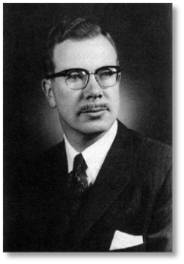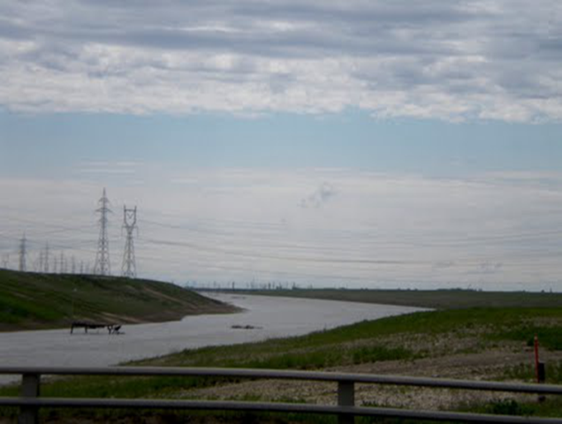

Red River Floodway (“Duff’s Ditch”)

Floods have always been a fact of life for Manitobans. In colonial days, settlers would flee to high ground at places like Bird's Hill. In the 1900s, however, Manitoba's population boomed and its building infrastructure expanded. The Great Flood of 1950 saw over 10,500 homes flooded (1/10th of Winnipeg). The great potential damage future floods could do became a major concern.

New dikes and pumps were put in place, but when the Department of Resources and Development's 1953 report recommended a huge river diversion channel be dug, Premier Douglas Campbell (1948-1958) hesitated at the cost. The succeeding Progressive Conservative government under Dufferin Roblin (1958-1967), however, leapt into construction of the Red River Floodway and other flood prevention projects. Critics nicknamed the floodway "Duff's Ditch" and "decried [it] as 'approximating the building of the pyramids of Egypt in terms of usefulness.'"

The floodway runs from just south of St. Norbert to the locks at Lockport (29 miles) and cost $62.7 million to construct. Manitoban companies moved more earth than it took to dig the Suez Canal, and 40% as much as the Panama canal. The St Lawrence Seaway took only two thirds the digging. Amazingly, they finished it without overruns in cost or time between 1962 and 1968.

The floodway proved its worth many times since 1950. Damage was minimized in floods of similar size in 1974 and 1979, and only 30 houses in Winnipeg flooded in the 1997 "Flood of the Century," the largest since 1826. South of St. Norbert, 28,000 Manitobans were evacuated as a lake five and a half times the size of Winnipeg formed, and Grand Forks, ND was inundated. Winnipeg was saved, but only just. The waters almost went around the floodway gates! The Floodway Expansion Project which concluded in 2010 doubled its capacity to accommodate the estimated size of a 1 in 700 year flood. It cost almost three times as much as the original project.

"Duff's Ditch" was designated as a National Historic site in 2006. Its success is a tribute to the fruits of Canada's heritage of enterprise and organization.

