East Selkirk Cemetery
Student Activities

Story 1: Immigration to St. Clements

a) Cemetery Whole Class Pre-Teaching
b) Cemetery Overview
c) Cemetery Exploration
d) Mapping the Cemetery

Story 2: Immigrant Families – Continuity and Change

a) Continuity and Change Venn Diagram
b) Locating Headstones

Story 3: Headstone Evidence
a) Collecting Headstone Information
b) Identifying Headstone Styles
c) Identifying Headstone Materials
d) Comparing Veteran Headstones
e) Creating a Glossary

East Selkirk Cemetery

Pre-Teaching:

Story 1: Immigration to St. Clements

As groups immigrated and settled in the area, they brought with them their homeland customs, religions and beliefs.

1. Invite discussion of prior knowledge of the settlement of the area we call Selkirk and East Selkirk.

Before Canada’s Confederation
Which groups of people lived in the area before the mass immigrations to Manitoba?
Why had people previously immigrated to Manitoba?

After Confederation
How had the Canadian government encouraged further immigration to Manitoba?
What main groups immigrated to Manitoba between 1867- 1914?

Students work individually or in groups to complete the first two columns of the following chart, then fill in the last column after the field trip.

Immigrating to East Selkirk

What I Know | What I Would Like to  Know | What I Learned

As settlements were established, people lived, prospered and eventually died in these areas. Churches and their communities laid their deceased to rest in local cemeteries. Historically, burial sites are a means for future generations to locate the final resting place of ancestors and prominent people in the community.

2. Discuss the churches that are affiliated with the cemetery.
How is the cemetery divided in respect to the affiliated churches?
How did this land become a cemetery? Who does the land belong to?

3. Honouring a person’s life by marking their burial location is a way to acknowledge the
person’s existence and an important memory for future generations.
Discuss the different markers and symbols on the headstones.

Online Resources:

Allow the students to go into the Red River North Heritage site:
https://redrivernorthheritage.com

4. Explore and discuss the website content relevant to the upcoming Cemetery Study.

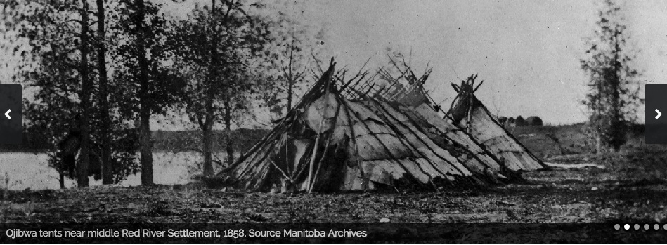

Story 1: Immigration to St. Clements – Cemetery Overview

Pre-trip :
Discuss the history of the Blessed Virgin Mary the Protectress and its importance to the immigrants. Look at how the church received the land for the cemetery and how it is divided.

At the cemetery:
Begin by exploring the site. Take photos or sketch the layout of the cemetery. Show the following:
1) Identify the number of sections. Do you see any difference in the sections? How are they identified?
2) Are there places where the people could have been buried with wooden markers? Where?
3) Are markers arranged in family clusters? What is the family name? Which direction do the headstones face? Do they all face that direction?

In the classroom:
Using any media create a map of the cemetery. Showing the information you looked for at the cemetery.

Story 2: Immigrant Families - Continuity and Change

Pre trip:
Encourage the students to learn about the immigrant experience through reading and discussing the stories of Mr. and Mrs. Wasyl Gerylo, Mr. and Mrs. Wasyl Kologinski, and Mr. and Mrs. Zahayko. Other family stories can be found online on the Red River North Heritage website. https://redrivernorthheritage.com/ in the digital version of the R.M. of St. Clements History Book beginning on page 433.
Use the Immigration Timeline and add the date when each family came to East Selkirk.

At the cemetery:

Try to locate a headstone for one of the three families: Gerylo, Kologinski or Zahayko. If you are successful sketch the headstone.

In the classroom:
Add the headstone you found to your map of the cemetery. Discuss continuity and change. Using the three articles create a Venn Diagram showing what life was like in East Selkirk from 1890-1910. The second circle will be what life is like today from 1999-2019.The intersecting circle will be what is the same or has continuity. Think of broad categories such as transportation, jobs, houses etc. (Looking at the Photos on the Red River North Heritage website may help students.)
Story 3: Immigration to St. Clements – Headstone Evidence

Pre-trip:
Brainstorm all of the information that you think can be found on a headstone. Create a chart with each piece of information as a heading. Examples: Person’s name, date of birth etc.
Discuss the St. Clements Immigration Timeline.
Add dates of important provincial, national and international events. What effect do you think any of those events have on immigration to St. Clements?

At the cemetery
Look for four interesting headstones. Record the information for each headstone on the chart below.

 | Birt | Date

In the classroom:
Insert the birthdates and death dates into the Immigration Timeline. What was happening in East Selkirk, Manitoba, Canada, world during their lifetimes?
Story 3: Immigration to St. Clements – Headstone Evidence

Pre trip :
Discuss the designs and symbols that can be found on headstones of people from East European Regions

At the cemetery:
Draw or take photos of at least three headstones that illustrate the Ukrainian background of the person. It may be the shape, the script, symbols or colours.

In the classroom: Create a good copy of one of the three headstones. Label the parts that show the Ukrainian influence.
Story 3: Immigration to St. Clements – Headstone Materials

Pre trip:
Discuss with students the type of materials used to make headstones. Provide pictures of the materials commonly used. Sandstone, limestone, marble, concrete, granite, field rocks, brick, metal or wood.
Discuss how the materials are influenced by the environment and different headstone materials are affected differently by the environment.

At the cemetery:
Have students bring the photos of the different materials used to make headstones. Find one headstone that has a date of death (DOD) for each one of the following decades. Record the date with the type of material used to make the headstone. Try to find 5 different decades.

Decade Date of Death Headstone Material

1900-1910

1910-1920

1920-1930

1930-1940

1940-1950

1950-1960

1960-1970

1970-1980

1980-1990

1990-2000

2000-2010

2010-2020

In the classroom:
Discuss your findings. Is there any difference between the materials used in each decade? Did you notice any difference in the erosion or wear on the different materials?
Which material seems to have the least erosion?
Story 3: Immigration to St. Clements – Veteran Headstones

Pre trip:
Read the story of a WWII veteran called Peter Kologinski (Cole). Why do you think he changed his name. What does that tell you about life for the Eastern European immigrants to East Selkirk? Could this be happening now in Canada?

In the cemetery:
Use the cemetery study for St. Peter Dynevor that has a section about two styles of veteran headstones.
Try to record all of the military information you can find on different veterans headstones.

In the classroom:
Research and create a glossary of al of the symbols and abbreviations, military units, ranks and perhaps wars you recorded from the veterans’ headstones.

